**OUTPUT (8a):**

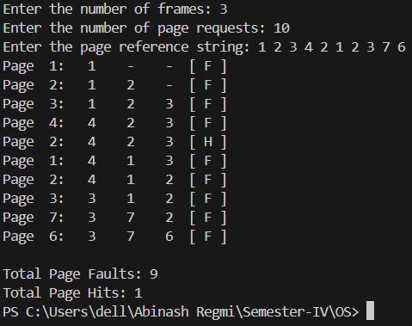

**OUTPUT (8b):**

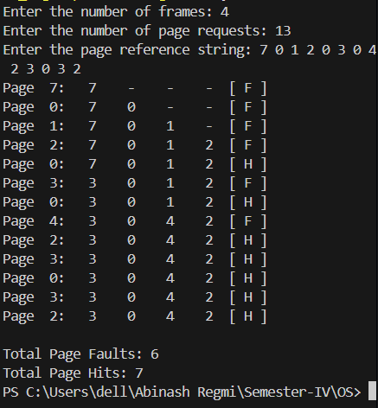

**OUTPUT (8c):**

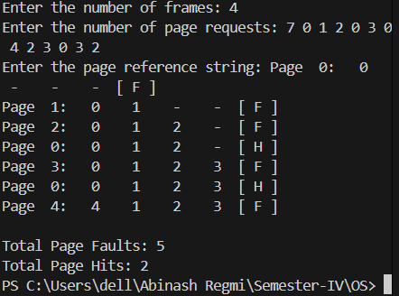

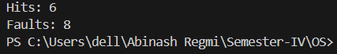**OUTPUT (8d):**

**OUTPUT(9a):**

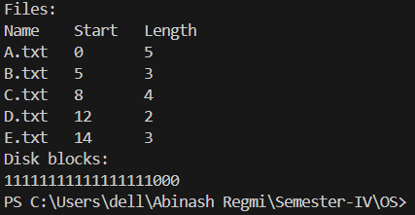

**OUTPUT(9b):**

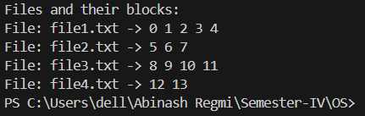

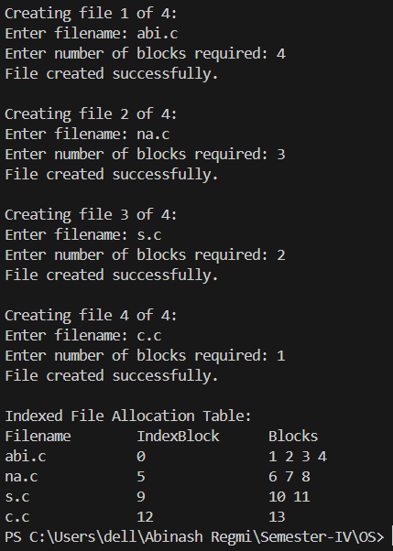**OUTPUT(9c):**

**OUTPUT (10a):**

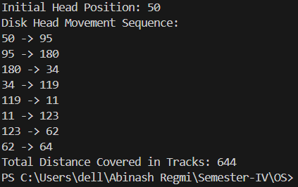

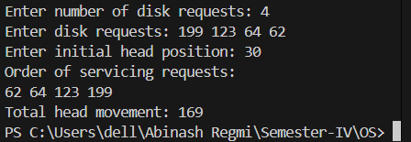**OUTPUT (10b):**

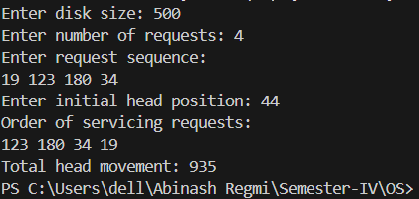**OUTPUT (10c):**

**OUTPUT (10d):**

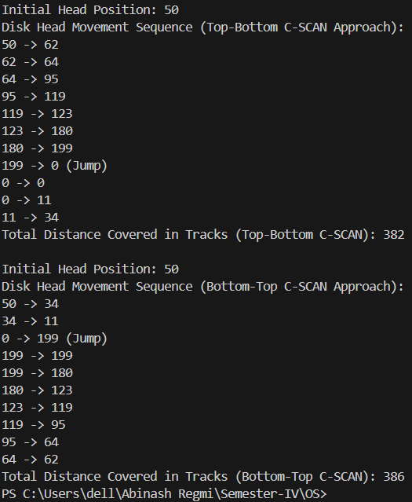

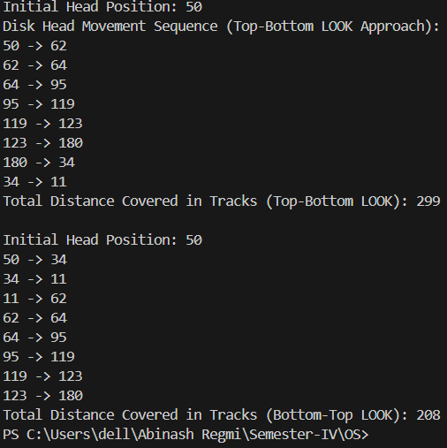**OUTPUT (10e):**

**OUTPUT (10f):**

